Amelia Ng

30593115 - Monday 4-6pm Studio (1000 words)

Visualisation 2 Report

<https://leafianna.github.io/fit3179/Assign2/index.html>

# Visualisation 2 Report

## Domain:

The topic of this report is tuberculosis (TB) and its global prevalence. It covers the concern of global public health and epidemiology. The visualisation aims to shed light on key aspects related to the incidence, prevalence, and funding of TB research on a global scale.

## Why:

The purpose of this report is to provide a comprehensive analysis of TB data, highlighting aspects such as incidence rates, mortality trends, risk factors, and funding disparities. By visualising this data, we aim to raise awareness about the persisting global burden of TB, the challenges faced in combating the disease, and the urgent need for increased investment in research and development. The report underscores the importance of addressing TB as a significant public health concern and advocates for reprioritised efforts to curb its spread and impact.

## Who:

This report is intended for policymakers, public health officials, healthcare professionals, researchers, and individuals interested in understanding the current state of TB globally. Tuberculosis requires more awareness and understanding to better combat the disease, to which this dashboard aims to assist with.

## Data

URL: <https://www.who.int/teams/global-tuberculosis-programme/data> , <https://ourworldindata.org/grapher/number-of-deaths-from-tuberculosis-by-world-region> , <https://ourworldindata.org/grapher/incidence-of-tuberculosis-sdgs>

Author: World Health Organization, Our World in Data

The World Health Organization (WHO) is a specialised agency of the United Nations responsible for international public health. The World Health Organization plays a vital role in combatting tuberculosis (TB) by providing data, research and resources for the process. (WHO, 2022)

Our World in Data is an independent research organisation that focuses on collecting, curating, and disseminating data and research to provide a comprehensive understanding of global trends and issues. Our World in Data collects data from a wide range of reputable sources, including international organisations, government agencies, academic institutions, and NGOs. (Team & Roser, 2023). OWID data was used to obtain continental information.

## Charts

## Choropleth Maps

Figure Fatality Map (%) of TB by Country

Figure Incidence Totals of TB per Country

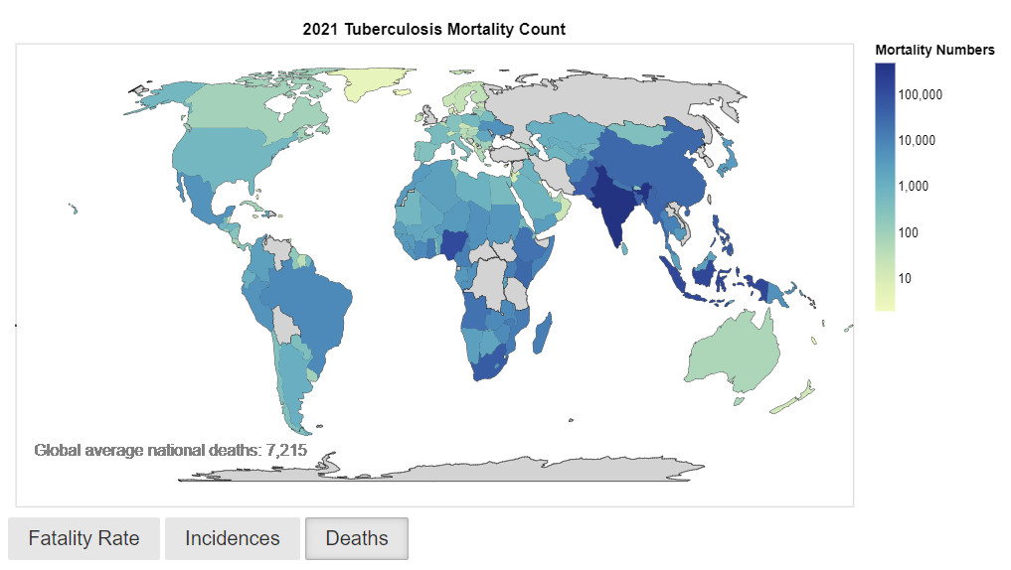

Figure Deaths Caused by TB by Country

Purpose: These three interactive choropleth charts provide a visual representation of the fatality rate, incidences, and deaths of tuberculosis by country in 2021. They serve to illustrate the global prevalence and distribution of TB cases, enabling viewers to grasp the geographic impact of the disease.

Features: The choropleth maps show a scale of the displayed variable and their severity per country. This allows for insights into specific countries' data points and observing the varying severity levels of tuberculosis across different regions.

Interactivity: The charts offer tooltips that display the name of each country along with their corresponding fatality, incidence, or death rate when the cursor hovers over a specific region. This feature enhances the accessibility and user engagement of the visualisations.

## Line

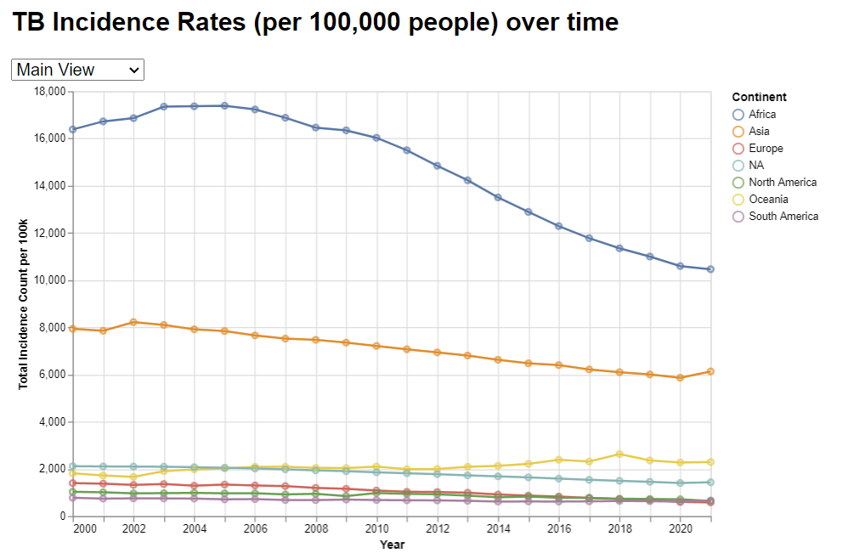

Figure Line Chart of Incidence Rates over Time

Figure Incidence Rates per continental region

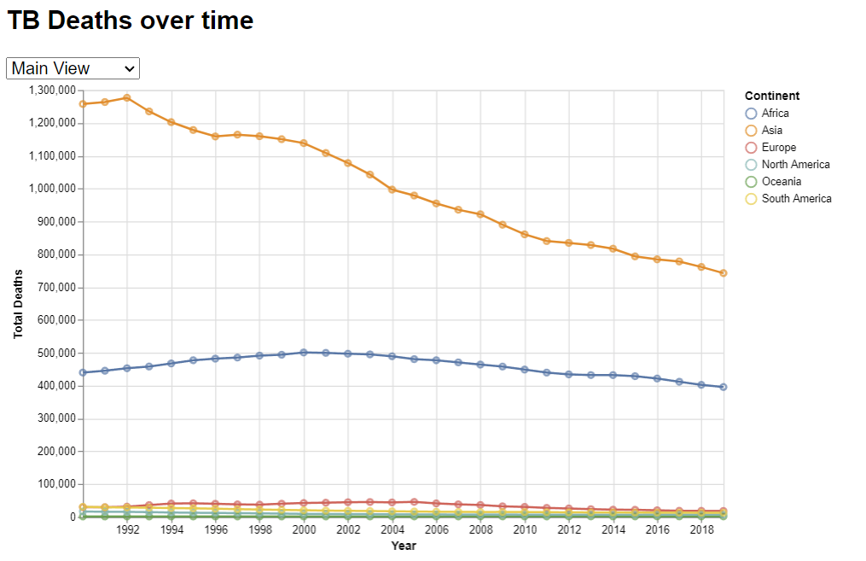

Figure Deaths of TB over time

Figure Deaths per continental region

Purpose: The visualisation depicts the total incidence count of tuberculosis per 100,000 people across various continents over the years, and death counts. It aims to illustrate the trends and patterns of tuberculosis incidence on a global scale, emphasising the impact on different continents and regions.

Features: The chart utilises a line graph to demonstrate the overall trend of the total incidence count per 100,000 people and deaths per continent, while also incorporating data points (shown as points) for each specific year. The interactive tooltips provide information about the continent, year, and corresponding total count, facilitating a comprehensive understanding of the dataset. The facets are auto adjusted to the data in terms of the y axes, allowing for better analysis and readability.

Interactivity: Viewers can hover over data points to see values, and toggle between main and regional view via dropdown. The facet representation further enhances the visualisation's capability to demonstrate regional disparities and trends, enabling users to analyse and compare the data across multiple continents simultaneously.

## Bar Chart

Figure Risk Factors associated to TB

Figure Estimated TB funding for each financial year

Purpose: The bar charts aims to illustrate the total expenditure allocated for tuberculosis (TB) control and management over the years and risk factors. It provides a clear overview of the financial investment dedicated to combating TB on a global scale.

The risk factor bar chart shows the total of associated cases with each risk factor, and their distribution.

Features: The funding chart features annotations to more easily view the estimated funding for each year. The primary purpose is to show the lack of significant change to TB funding over the years.

The risk factor bar chart also contains annotations for clarity of each total.

Interactivity: Users can interact with the both charts to obtain detailed information about the specified variables (total cases, budget) for each year. The tooltips provide the full values unabbreviated.

## Design

### Layout:

I structured the dashboard using Pure.css. The aim was to mimic a typical web page and place all info on one scrolling page. The graphs were placed in either centred or half-page-width divisions.

### Colour:

Used colour-blind safe palettes such as yellow-green-blue for the countries. Used grey background on the sides of the page to highlight the graphs and text content.

### Figure-ground

Each section was titled in a consistent font, and the same consistent ratios, groupings and sizes for graphs and text was used to show proximity and therefore relation.

Negative spacing was used around the texts and aligned with their respective sections to show collation. (*Pure*, 2022)

### Typography:

Used Lato font consistently for the whole of the dashboard, as it is a sans serif font. Headings were given bolding and/or heavier weighting.

### Storytelling:

The storytelling is done by the layout of the dashboard, as the user is guided downwards scrolling through the page. The user can interact with all the graphs via hover tooltip, buttons etc. There is text analysis on graphs that continue the story, emphasising the need for awareness of TB and its issues. Related text and graphs are placed either within heading or sections, emphasising relation by proximity.

### Dashboard Full Image

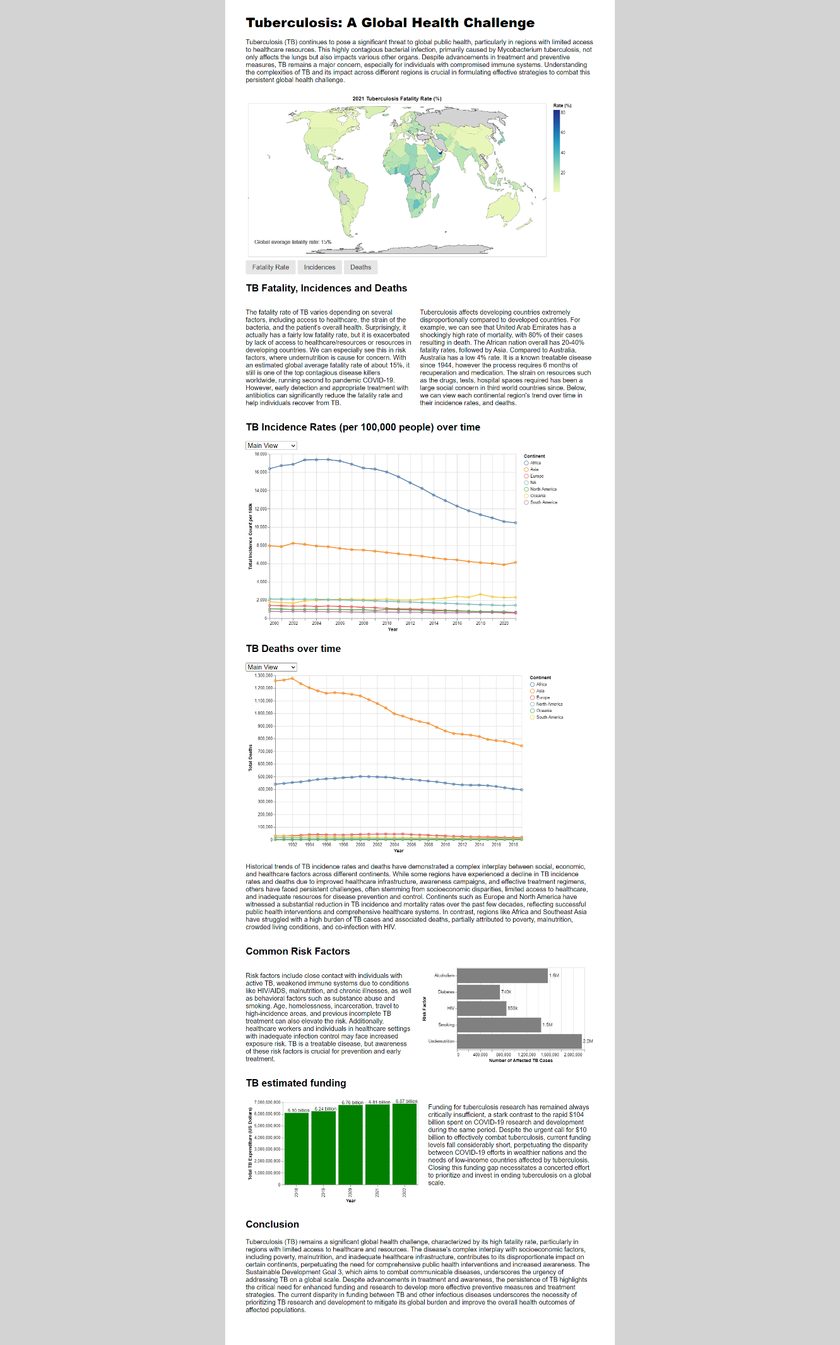

## References

*MIT License*. (2023, September 15). Choose a License. https://choosealicense.com/licenses/mit/

*Pure*. (2022). https://pure-css.github.io/

Team, O. W. in D., & Roser, M. (2023). Ensure access to affordable, reliable, sustainable and modern energy for all. *Our World in Data*. https://ourworldindata.org/sdgs/affordable-clean-energy

WHO. (2022). *About Global Tuberculosis Programme*. https://www.who.int/teams/global-tuberculosis-programme/about

## Appendix:

### Licensing:

MIT License (*MIT License*, 2023)

Copyright (c) [year] [Amelia Ng]

Permission is hereby granted, free of charge, to any person obtaining a copy

of this software and associated documentation files (the "Software"), to deal

in the Software without restriction, including without limitation the rights

to use, copy, modify, merge, publish, distribute, sublicense, and/or sell

copies of the Software, and to permit persons to whom the Software is

furnished to do so, subject to the following conditions:

The above copyright notice and this permission notice shall be included in all

copies or substantial portions of the Software.

THE SOFTWARE IS PROVIDED "AS IS", WITHOUT WARRANTY OF ANY KIND, EXPRESS OR

IMPLIED, INCLUDING BUT NOT LIMITED TO THE WARRANTIES OF MERCHANTABILITY,

FITNESS FOR A PARTICULAR PURPOSE AND NONINFRINGEMENT. IN NO EVENT SHALL THE

AUTHORS OR COPYRIGHT HOLDERS BE LIABLE FOR ANY CLAIM, DAMAGES OR OTHER

LIABILITY, WHETHER IN AN ACTION OF CONTRACT, TORT OR OTHERWISE, ARISING FROM,

OUT OF OR IN CONNECTION WITH THE SOFTWARE OR THE USE OR OTHER DEALINGS IN THE

SOFTWARE.